***PWE LOCALIZATION TOOL***

Whenever there is an update to the game that changes any text, we receive an updated localize.data file. This file is opened with a program called Elementlocalize. Elementlocalize displays all text present in the game, with both English and base language (Chinese, in the case of our other titles) entries.

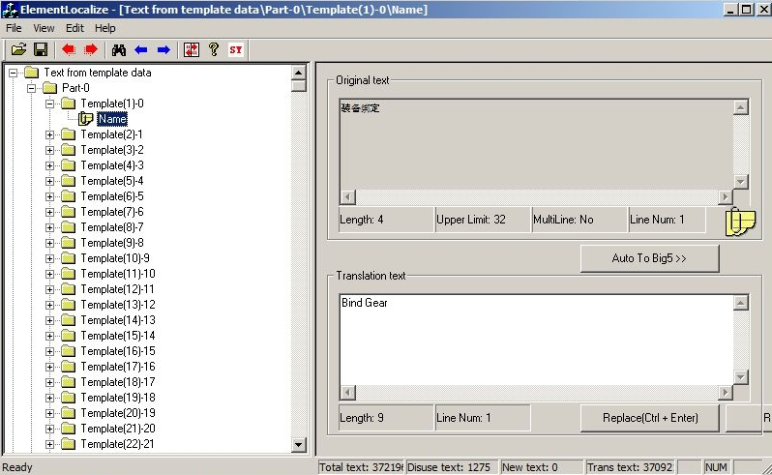

When we wish to change any text, we search Elementlocalize for that entry. In the example I will be changing the name of an item, “celebean” into “mana bean.” The first step is to search for the English text I wish to change.

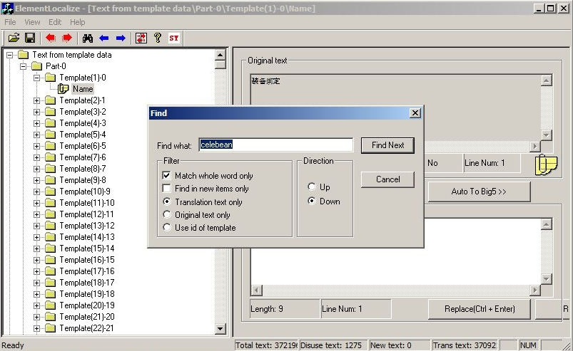

Once we locate the entry we wish to modify, we can write the text directly into Elementlocalize. Elementlocalize knows the character and line limits of every text field in the game and will inform us if our changes exceed these boundaries.

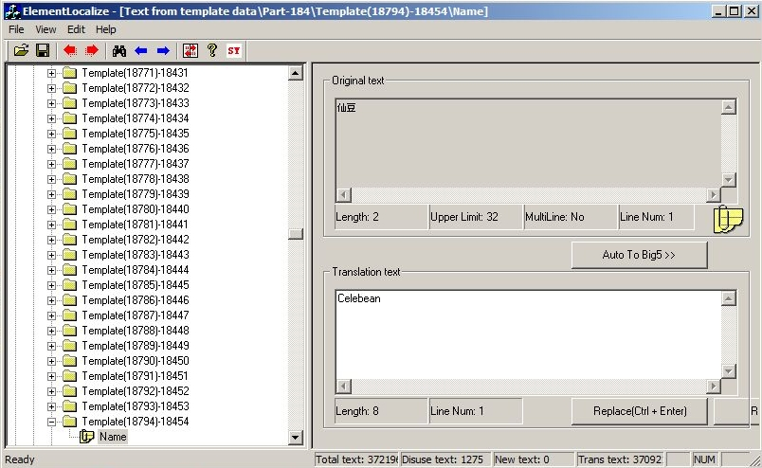

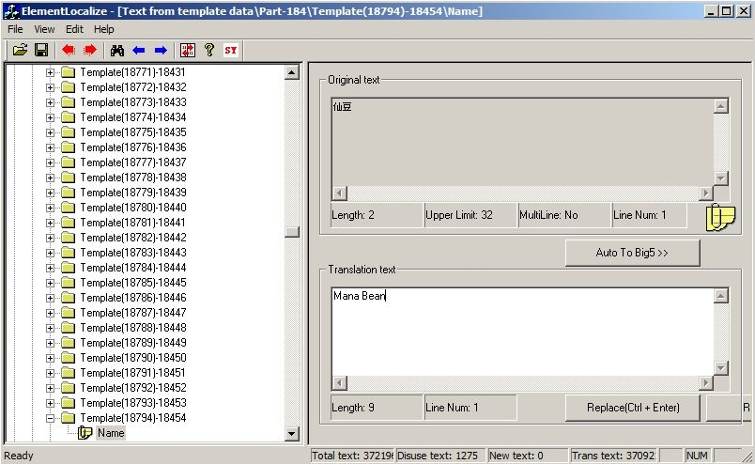

We can also double-check this entry within the game itself by clicking the Replace button and then selecting Export Game Data and pointing the program to our game install directory. This modifies our individual versions of the game to display our text changes and allows us to make sure the new text appears correctly in game.

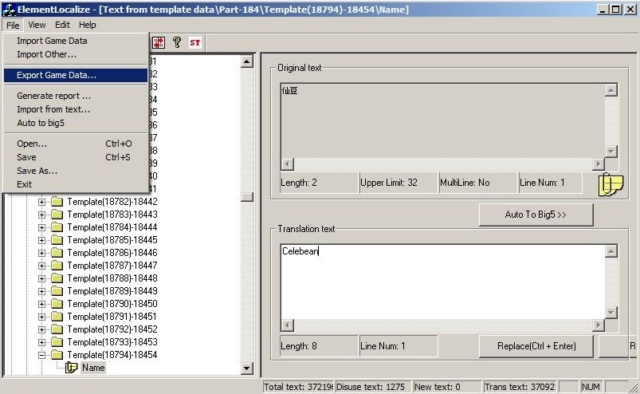

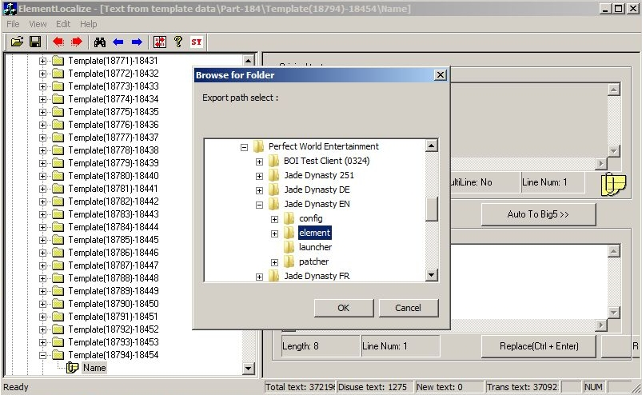

Once we have established that there are no length or display issues with the new text, it is time to write a localization bug. With Elementlocalize, we now know the base language entry for the text we want to modify. We always include this information in our bug reports for the benefit of the developers who may not speak English as a first language or at all.

As going through each bug report for individual text changes can be time consuming, we aggregate all text changes within Excel documents and send these off to the developers at the end of each work day. This highlights another useful function of Elementlocalize: generating localization documents. By selecting the Generate Report option, we can transfer all text contained within Elementlocalize, that is to say all text in the game, into a single Excel document with both the base language and the current English translation. This document is referred to generally as the game’s Localization Document or Loc Doc.

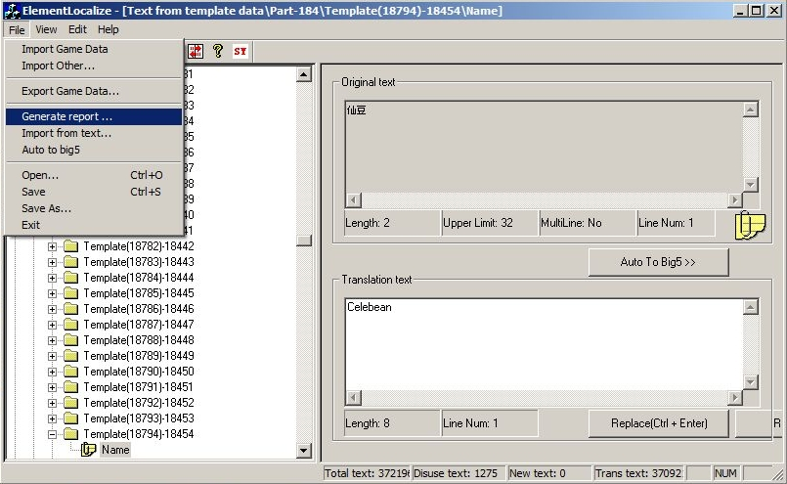

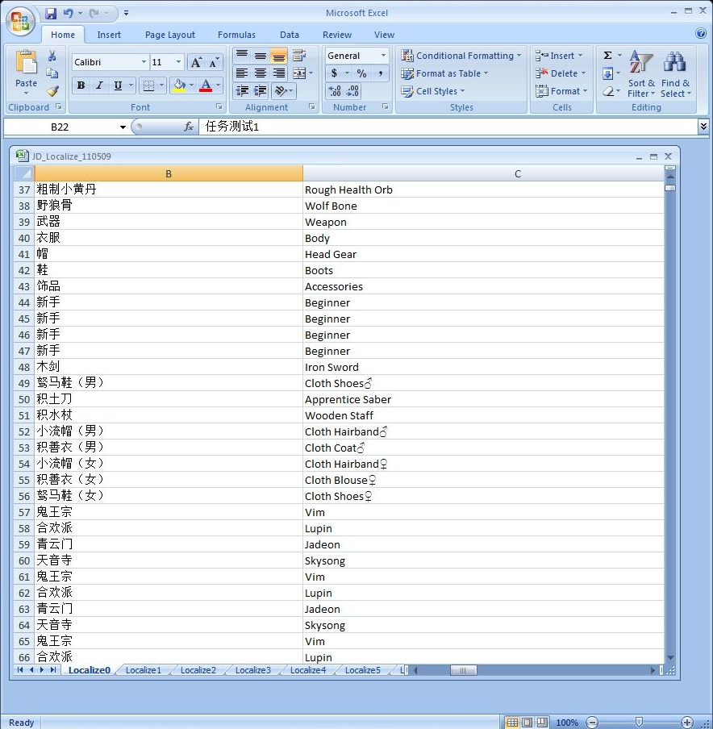

We collect the cells for the base language and current translation, and copy them over to a second Excel document. This is our daily change log that we send off to the development team and it contains the base language text, current English text, requested English text and the number of the bug report. The development team uses this information to implement our requested change as well as track which changes they have addressed within our database. The next day, the development team will provide us with an updated client version that contains this newly-added text, as well as an updated localize.data file.

Other Advantages of this System include:

1. Ease of Regression: Receiving updated documentation with every new client version allows us to track the implementation of our text bugs without having to go in game and view them directly. This saves dozens of man-hours of work weekly, per title, as we can search Elementlocalize or our updated Localization Document to see if our changes have been implemented.
2. Global Changes: Having a searchable tool allows us to implement text changes with a wide scope without having to track down each and every instance of where that text appears in game. If we wanted to change an NPC’s name, we could simply search for that name in our Localization Document, grab all the instances of the name and include all in the daily change log.
3. Consistent Base Language: Having access to the base language text means that tracking any old issue becomes much clearer and more precise. If we are trying to track the history of an NPC whose name has been multiple times, we need only search for the base language entry for that name to see all related bug reports.